Morris Literacy Project: ESL Beginning Geography Local Map: Picture Fill-In-Word Activity


Write the missing letters for each fill-in-word:
- ga_ s_tati_n
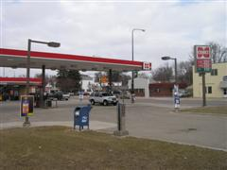

- p_st o_fice
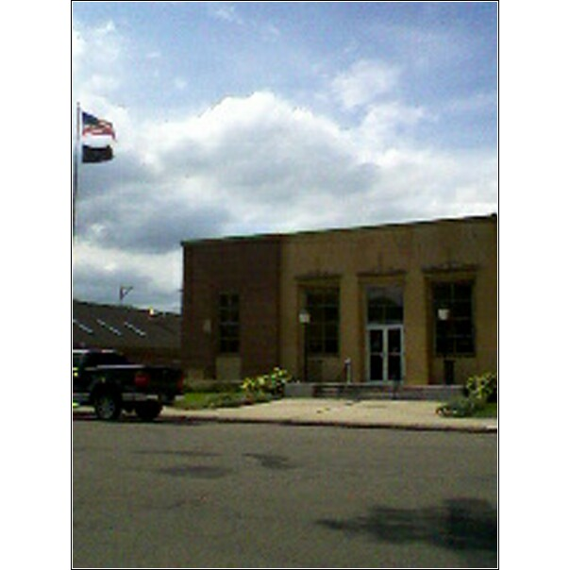
- _ir_ t_uck
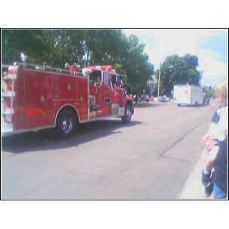

- s_or_
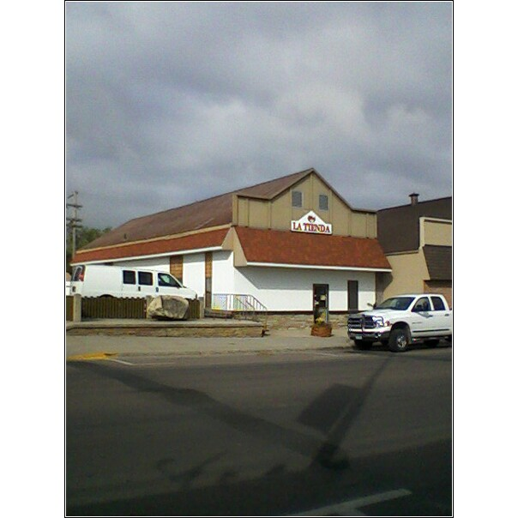
- p_lice ca_
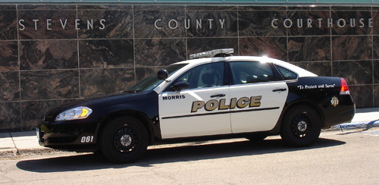
- fi_e de_art_ent
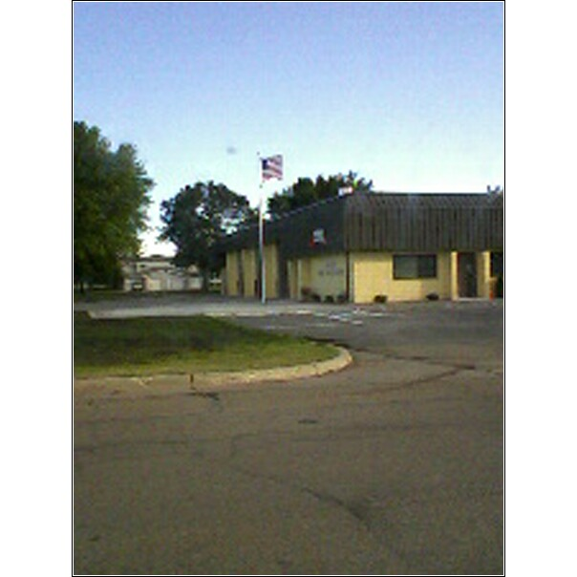

- gro_ery _tore
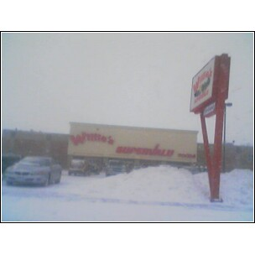
- rest_ur_nt


